**ECE 20100 – Fall 2015**

**Final Exam**

**December 17, 2015**

**Sections:**

Cui (3:30) – 0002 Yong (11:30) – 0004 Tan (1:30) – 0005

Zhu (2:30) – 0011 Peleato-Inarrea (10:30) – 0012

***Instructions***

1. DO NOT START UNTIL TOLD TO DO SO.
2. Write your name, section, professor, and student ID# on your **Scantron** sheet. We may check PUIDs.
3. This is a CLOSED BOOKS and CLOSED NOTES exam.
4. The use of a TI-30X IIS calculator is allowed.
5. If extra paper is needed, use the back of test pages.
6. Cheating will not be tolerated. Cheating in this exam will result in, at the minimum, an F grade for the course. In particular, **continuing to write after the exam time is up is regarded as cheating**.
7. If you cannot solve a question, be sure to look at the other ones, and come back to it if time permits.

**Question 1**

Given that the charge *q*(*t*) in a conductor is as shown in the graph below, find the current through the conductor for the time period 2 < *t* < 4 sec.



(1) 0 A

(2) 0.5 A

(3) 1.0 A

(4) 1.5 A

(5) 2.0 A

(6) 3.0 A

(7) 4.0 A

(8) none of above

Solution: 5

**Question 2**

Which of the following is true for the current source labeled as “−3A”:

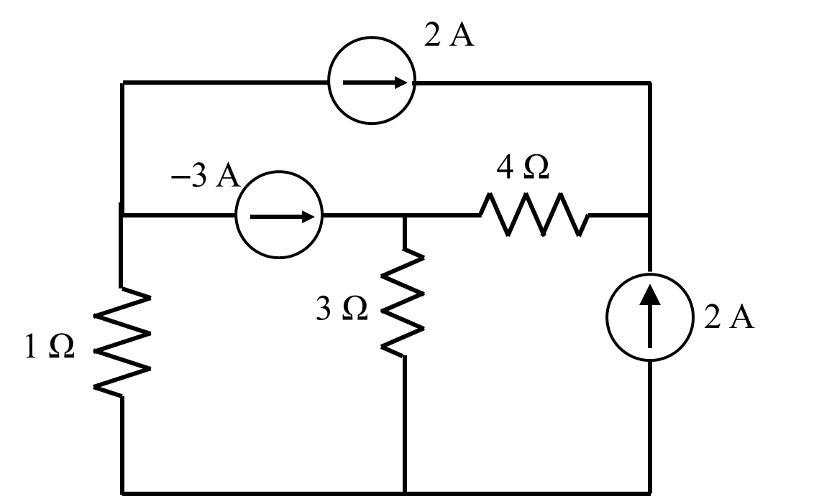

Answers:

1. It delivers 3W of power.
2. It absorbs 3W of power.
3. It delivers 6W of power.
4. It absorbs 6W of power.
5. It delivers 9W of power.
6. It absorbs 9W of power.
7. It delivers 27W of power.
8. It absorbs 27W of power.
9. It delivers 36W of power.
10. It absorbs 36W of power.

Solution: 4

**Question 3**

Find the correct nodal equation for node A.

(1) $I_{S}+i_{x}+V_{0}-V_{S}=0$

(2) $I_{S}+i_{x}+V_{0}-{0.5 V}_{S}=0$

(3) $I_{S}+i_{x}+{0.5 V}_{0}-V_{S}=0$

(4) $I_{S}+i_{x}+{0.5 V}_{0}-0.5 V_{S}=0$

(5) $I_{S}-i_{x}-0.5 V_{0}+0.5 V_{S}=0$

(6) $I_{S}-i_{x}-0.5 V_{0}-0.5 V_{S}=0$

(7) $I_{S}-i_{x}-V_{0}+{0.5 V}_{S}=0$

(8) $I_{S}-i_{x}-V_{0}-0.5 V_{S}=0$

Solution: 7

**Question 4**

For the circuit below, pick the correct mesh equations for the two loops as shown below.



(1) ${5 I}_{1}+4 I_{2}=1; I_{2}=-0.5 A$

(2) ${4 I}_{1}+5 I_{2}=1; I_{2}=-0.5 A$

(3) $I_{1}+4 I_{2}=1; I_{2}=-0.5 A$

(4) ${4 I}_{1}+I_{2}=1; I_{2}=-0.5 A$

(5) ${5 I}_{1}+4 I_{2}=1; I_{2}=0.5 A$

(6) ${4 I}_{1}+5 I_{2}=1; I_{2}=0.5 A$

(7) ${ I}_{1}+4 I_{2}=1; I_{2}=0.5 A$

(8) ${4 I}_{1}+I_{2}=1; I_{2}=0.5 A$

Solution: 1

**Question 5**

Find the Thevenin equivalent from the perspective of the inductor:

1. Vth = 0 V Rth = 20 
2. Vth = 0 V Rth = 25 
3. Vth = 0 V Rth = 30 
4. Vth = -10 V Rth = 10 
5. Vth = -10 V Rth = 20 
6. Vth = -10 V Rth = 30 
7. Vth = -25 V Rth = 10 
8. Vth = -25 V Rth = 25 
9. Vth = -25 V Rth = 30 

**Question 6**

If conductances, G1 and G2, and transconductance, gm, all double in value, find the new value of V2:

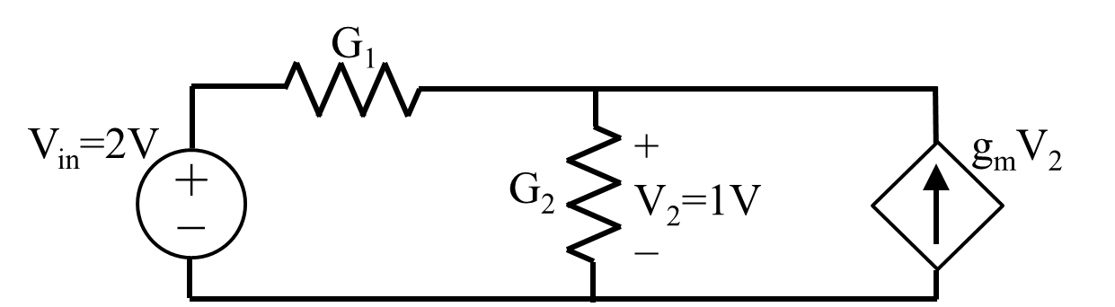

Answers:

1. 0.5V
2. 1 V
3. 2 V
4. -0.5V
5. -1V
6. -2V
7. 0V
8. 3V
9. -3V
10. None of the above

Solution: 2

**Question 7**

The time constant for the following LR circuit is:

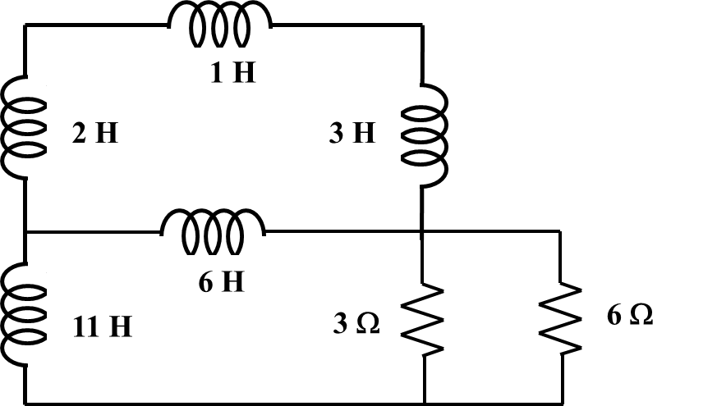

(1) 1 sec. (2) 2 sec. (3) 3 sec. (4) 4 sec.

(5) 5 sec. (6) 6 sec. (7) 7 sec. (8) 8 sec.

(9) 9 sec. (10) 10 sec.

Answer: 7.

**Question 8**

In the circuit below, the switch is closed at t = 0 sec. Find the capacitor voltage (vc) at t = 1 sec.

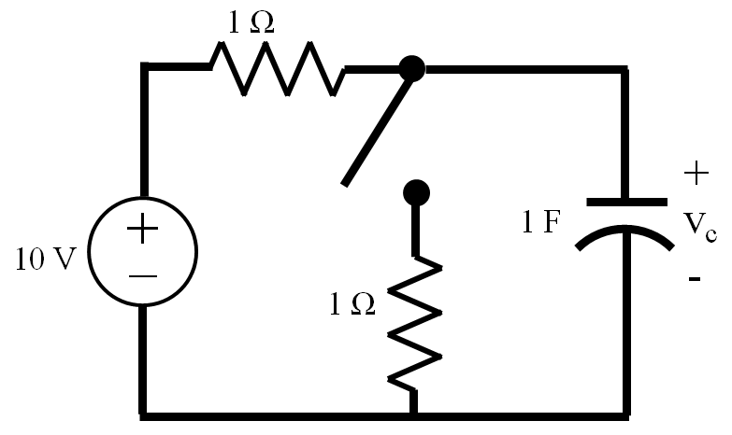

1. 0.68 V
2. 1.35 V
3. 3.68 V
4. 5 V
5. 5.68 V
6. 6.84 V
7. 10 V

Answer: (5)

**Question 9**

Find vC(t) for t ≥ 0 assuming vC(0-) = 1V and iL(0-) = 1.5 A.

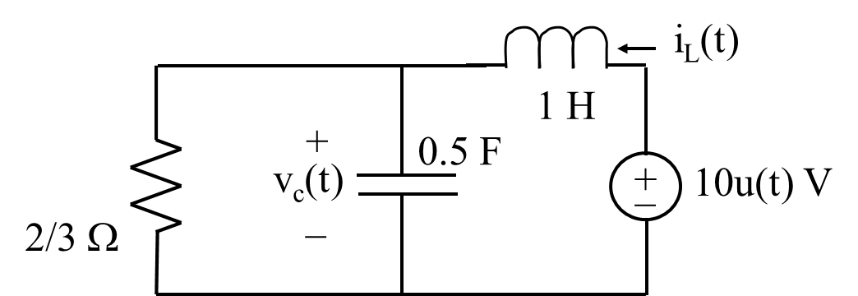

(1) vC(t) = (18 + 9e2t +10e3t ) V

(2) vC(t) = (9 – 5e2t +10e3t ) V

(3) vC(t) = (18 + (10+5t)e3t ) V

(4) vC(t) = (10 – 18 et + 9 e-2t ) V

(5) vC(t) = (18 + e3t [A cos (11.87t) +B sin (11.87t)])V

(6) vC(t) = (9 + e2t [A cos (11.87t) +B sin (11.87t)])V

(7) vC(t) = (18 – 10e2t +5e3t ) V

(8) vC(t) = (9 + 3et + 6e2t ) V

(9) vC(t) = (18 + (6+ 6t)e2t ) V

(10) vC(t) = (9 – (18+ 9t)e2t ) V

Answer: (4)

**Question 10**

Consider an ideal amp connected in the following circuit, what is the value of the voltage output Vout?

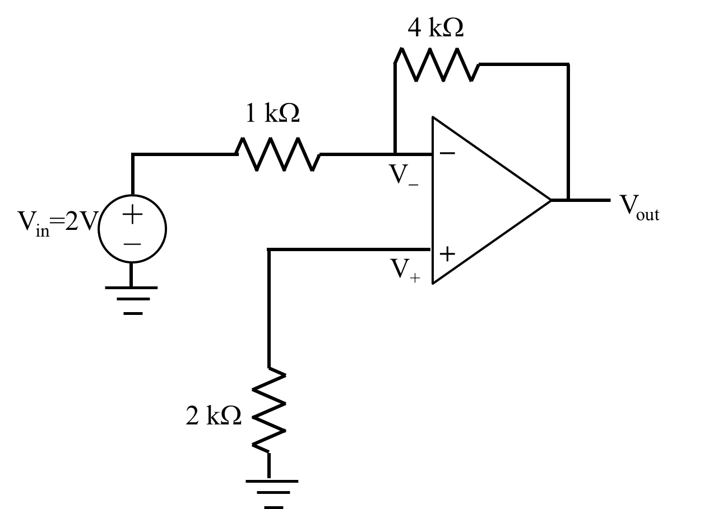

(1) Vout = −10 V;

(2) Vout = −8 V;

(3) Vout = −4 V;

(4) Vout = −2 V;

(5) Vout = 0 V;

(6) Vout = 2 V;

(7) Vout = 4 V;

(8) Vout = 8 V;

(9) Vout = 10 V;

(10) None of the above.

Answer: (2)

**Question 11**

In the following circuit, the capacitance C is (in F):

**(*Hint: write down the admittance of the two branches*)**

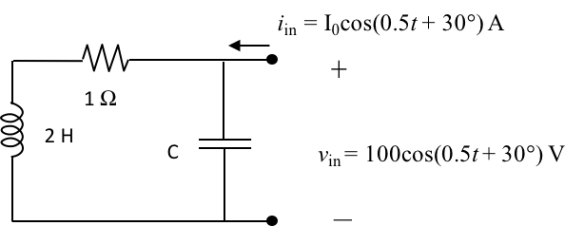

(1) 0.25 (2) 0.5 (3) 1 (4) 2 (5)3   
(6) 4 (7) 30 (8) 50 (9) 60 (10) 100

**Answer 3**

**Question 12**

Find the downward current through the inductor if Vs(t) = 200 cos(20 t) and Is(t) = 10 cos(10 t). (Observe that the frequencies are different). Choose the closest answer.

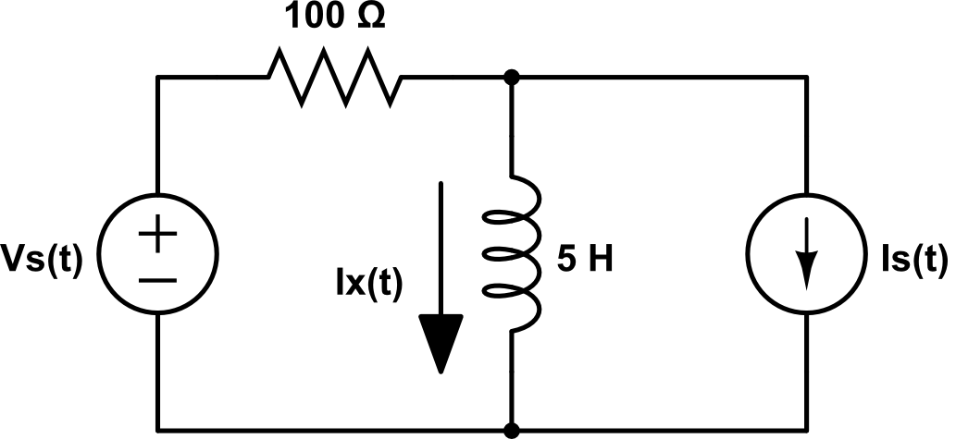

(1) Ix(t) = $√2$ cos(20 t - 45°) - 9 cos(10 t – 26.6°) Amp

(2) Ix(t) = 5.65 cos(20 t + 135°) Amp

(3) Ix(t) = -7.15 cos(10 t - 26°) Amp

(4) Ix(t) = 2 cos(20 t) – 10 cos(10 t) Amp

(5) Ix(t) = - 10 cos(10 t) Amp

(6) Ix(t) = 2 cos(20 t) Amp

(7) Ix(t) = 0 Amp

**Question 13**

In the circuit shown below, VS(t) = 100cos(100t) V. Find the average power absorbed by the capacitor.



(1) 0 W

(2) −0.2 W

(3) 0.2 W

(4) −1.0 W

(5) 1.0 W

(6) −4.7 W

(7) 4.7 W

(8) none of above

**Answer 1**

**Question 14**

A voltage changes over time according to the following graph. What is the effective value of the voltage in volts?

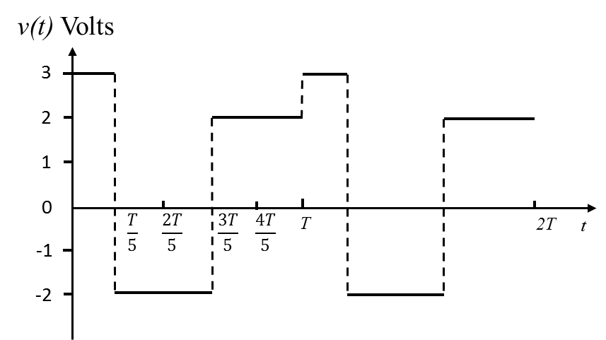

(1) 1 (2) 1.5 (3) $\sqrt{3}$ (4) $\frac{3}{5}$ (5) $\sqrt{5}$ 
(6) $\sqrt{6}$ (7) $\sqrt{7}$ (8) $\sqrt{8}$ (9) 3 (10) 0.5

**Answer 5**

**Question 15**

The average power delivered by the voltage source is:

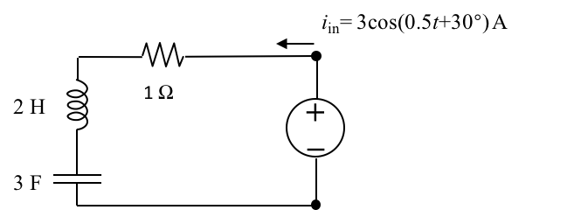

(1) 1 W (2) 2 W (3) 3 W (4) 4 W (5)3.5 W   
(6) 4.5 W (7) 9 W (8) 18 W (9) 27 W (10) 0 W

**Answer 6**

**Question 16**

An industrial machine requires 40 kW with power factor 0.8 lagging and a voltage of 220 Vrms. Find the reactive power that it is consuming.

(1) - 50 VAR

(2) - 30 VAR

(3) - 10 VAR

(4) 0 VAR

(5) 10 VAR

(6) 20 VAR

(7) 30 VAR

(8) 40 VAR

(9) 50 VAR

(10) None of the above

**Question 17**

In the circuit below, a 60 Hz sinusoidal voltage source (**V**s) drives a motor. The terminal voltage of the motor (**V**m) is 100 V (rms value). The average power of the motor is 100 W and its power factor is 0.8 lagging. Find the power consumed by the 0.64 Ω resistor.

1. 0 W
2. 0.32 W
3. 0.64 W
4. 1 W
5. 1.414 W
6. 2 W

Answer: (4)

**Question 18**

Find the apparent power **generated** by the source in the following circuit. Choose the closest answer:

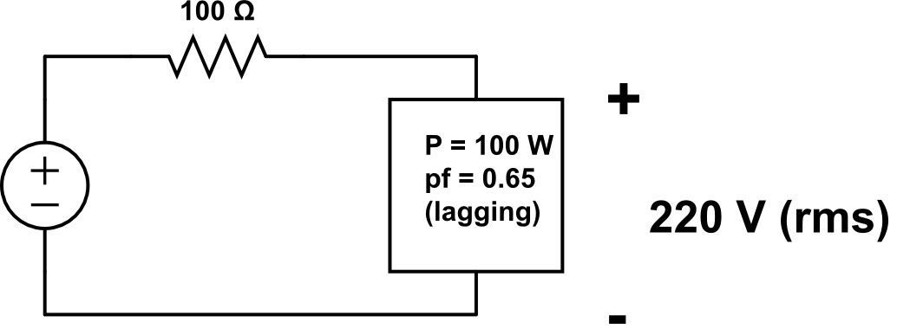

(1) S < 0 VA

(2) S = 0 VA

(3) S = 30 VA

(4) S = 80 VA

(5) S = 100 VA

(6) S = 125 VA

(7) S = 150 VA

(8) S = 170 VA

(9) S = 190 VA

(10) S >200 VA

**Question 19**

In the circuit below, a 230 V rms, 60 Hz sinusoidal voltage source (**V**s) drives a motor rated at 50 kW, pf = 0.8 lagging. A capacitor is added to increase the power factor to 0.9. Find the capacitance needed to increase pf to 0.9.

1. 0 F
2. 2.50 x 10-4 F
3. 3.22 x 10-3 F
4. 4.6 x 10-4 F
5. 5.32 x 10-3 F
6. 6.66 x 10-4 F

Answer: (6)

**Question 20**

Consider an AC circuit in sinusoidal steady state. Find the maximum possible average power (Pmax) absorbed by an adjustable load (ZLoad).

(1) Pmax = 400 $\sqrt{2}$ W;

(2) Pmax = 400 W;

(3) Pmax = 200 $\sqrt{2}$ W;

(4) Pmax = 200W

(5) Pmax = 100 $\sqrt{2}$ W;

(6) Pmax = 100 W;

(7) Pmax = 100 $/\sqrt{2}$ W;

(8) Pmax = 50 W;

(9) Pmax = 0 W (no net power absorbed);

(10) None of the above.

Solution: (6)

**Potentially Useful Formulas (2nd Midterm)**

 , where  or 

 



Elapsed time formula: t2 - t1 =  ln[(X1 - x(∞))/(X2 - x(∞))]

**Potentially Useful Formulas (3rd midterm)**

First order circuit: ,  = L/R or  = RC

Series RLC: 

Parallel RLC: 







, where 









**Potentially Useful Formulas (since Exam 3)**



 VA

 , 